 Alpha Phi Omega
Presents

Rowan University
April 8, 2000
Alpha Phi Omega
Nu Theta Chapter
Rowan University

Glassboro, NJ 08028

Dear Brothers,

The Nu Theta Chapter of Alpha Phi Omega, cordially invites you to attend

Spring Sectionals 2000 – A Day with Pink Floyd

The conference is being held on Saturday, April 8, 2000. Registration begins at 8 a.m. Cost is $20 in advance, and $23 at the door. We will be offering a wide variety of workshops, covering various topics. Service Projects during the conference include making Easter Baskets for a children’s shelter, campus clean-up, and an introduction to First Aid.

And wear your letters! Let’s see what chapter can show the most APO spirit.

So come on down and join the fun, it definitely worth the trip!

For More Information:
E-mail <apo_nutheta@hotmail.com>
Phone 856-256-6643 (Adam Traegar)
856-782-0679 (Stephanie McManus 10 a.m.-9 p.m. only)

The Days Events

8-8:45 a.m. Registration and Continental Breakfast
The Thin Ice—Ice Breakers to get to know your fellow
Brothers

9-9:30 a.m. Opening Remarks

9:45-10:30 a.m. Workshop Session #1
SAC Meeting

10:45-11:30 a.m. Workshop Session #2

11:30a.m.-12:45p.m. Lunch

1-2:30 p.m. Service Projects & Educationals

2:30-4 p.m. Workshop Session #3

4-5:30 p.m. Business Meeting

5:30-7 p.m. Roll Call, Awards, and Closing Remarks

**NOTE—There will not be a banquet. Brothers from Nu Theta will be going to a local restaurant for dinner after the conference, and anyone who wishes to join us may feel free. Cost is on your own.

11 p.m. Pink Floyd’s The Wall
Laser Show in Philadelphia
Cost $8 per person

Workshops

Service Roundtable Discuss what makes an effective service project, as well as the different organizations that you do service projects for. Receive project evaluation forms, as well as contact information for various National and Local organizations.

Pledge Roundtable Here is an opportunity for pledges to get together and discuss the different aspects of their pledge program. They are the future pledge educators, what better way for them to get information on additional options to the pledge program than by talking with pledges. This workshop is for pledges only!

National History Celebrate the 75th Anniversary of your fraternity by getting back in touch with what we stand for. This workshop will review the National History of APO, and remind us all of the reasons we became brothers in the first place.

When Brothers Date Brothers In life you will meet people that you are interested in, in some of the most unlikely places. When you meet these people either through the fraternity (i.e. a pledge, brother, alumni) or through your job (i.e. Co-worker, boss, subbordinate) it puts an added strain on your relationship both in and out of the organization. In this workshop we will discuss the different approaches to coping with being in a relationship with someone in the fraternity.

Life After APO If you are like many seniors, you are counting down the days until graduation. Here is your opportunity to find out more about the programs that APO has to offer you as alumni. Find out about becoming an advisor, staff member, and even a Life Member.

Rush Workshop Looking for new ways to recruit potential brothers? Well here is your chance! Not only will you exchange ideas with brothers and pledges from other chapters, but you will also get copies of the national rush publications, and examples of rush flyers & shirts form other chapters.

Fundraising A chapter can not function with out a budget. Learn how to create an effective budget, as well as plan and execute fundraising projects. This is a great workshop for anyone interested in being chapter Treasurer or Fundraising Chair.

Utilizing Your Alumni Do you have an alumni association at your chapter? What about a newsletter to update alumni as to what is going on? Either way come out and tell us about it! Let us know what you expect form your alumni, and what you do for them. And alumni, come out and be heard. Tell us what you are willing to do for your chapter, and what you want to know.

Fellowship Roundtable Although our primary focus is service, APO's like to have a good time. Compare ideas on what makes an effective fellowship event. Also, discuss the varying trends in Rush Event socials, Big/Little nights, formals, and parties. Discover the basics of event planning, including the little used fact that all prices are negotiable!

Membership Retention This is an opportunity for brothers to brainstorm on what is needed to keep other brothers active. Find out why some people leave APO, and how to overcome these obstacles.

Parliamentary Procedure Learn the basics of Robert's Rules of Order. Whether you are a Sgt.-at-Arms, Parliamentarian, or a President these are the basics for an effective meeting.

Letter Making Back by popular demand learn to make your own letters. Bring a plain T-shirt and we will supply the rest. There is an additional cost of $3 for this workshop.

Service Boy

Our Service Boy project for this semester will benefit Together Inc., a local children’s shelter in Gloucester County. We are asking that Brothers bring any of the following much needed supplies to Sectionals, so that we may make a difference in the lives of these children.

Loose Leaf Paper
- Chalk
- Bags of Pens or Pencils
- Erasers
- Glue
- 1-subject Notebooks
- Copy Books
- Crayons
- Bath Towels
- Wash Cloths

50/50 Raffle

Cost:
3 tickets for $1
Arms length for $5
Fingertips to Fingertips for $10

The Winner will receive half of the money raised.

The Winner’s Chapter gets to choose which organization they would like the remaining 50% of the money donated to.

Please fill out the following and include with your registration:

School & Chapter _________________________________________________________

Name of the organization you would like money donated to if one of your brothers win the 50/50.
________________________________________________________________________

Address of the Benefiting Organization
________________________________________________________________________
________________________________________________________________________
________________________________________________________________________

Phone Number (_____)_____________________________

What does this organization do?
________________________________________________________________________
________________________________________________________________________
________________________________________________________________________
________________________________________________________________________
________________________________________________________________________
The Show Must Go On

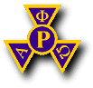

The brothers at Nu Theta want to make this a special conference for all of the pledges. What better way to do this than to initiate them into the Brotherhood during the conference.

We will be inducting our pledges during the time slot labeled The Show Must Go On/Free Time. We invite all of you to induct your pledges with us at that time.

If you choose not to induct your pledges at the conference, brothers are still welcome to attend the ceremony.

If your chapter would like to induct your pledges into the Brotherhood of Alpha Phi Omega during the conference, please e-mail Stephanie McManus <apo_nutheta@hotmail.com> with a list of those to be inducted by Saturday, April 1st.

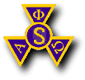

Directions to Rowan University
From the North (Northern New Jersey, New York, etc.)
Take the N.J. Turnpike South to Exit 2 and follow Route 322 East to the campus.

From Philadelphia
Take the Walt Whitman or Benjamin Franklin Bridge to I-676 South toward Atlantic City. Shortly after I-676 becomes Route 42 South, exit right, onto Route 55 South. Take Route 55 South to exit 50A (Glassboro-Mullica Hill). Take Route 322 East to the campus.

From the West
Take I-95 to the Commodore Barry Bridge. Follow Route 322 East to the campus.

From Central New Jersey
Take Route 70 West to I-295 South. Follow Route 295 to Route 42 South (Atlantic City). Exit Route 42 South onto Route 55 South to exit 50A (Glassboro-Mullica Hill). Take Route 322 East to the campus.

From the East
Take the Garden State Parkway to the Atlantic City Expressway. Take the Expressway to Exit 38 (Williamstown). Turn left after exiting and follow Route 322 West to the campus.
From the South (Maryland, Delaware, etc.) Take I-95 North to the Delaware Memorial Bridge. Take the N.J. Turnpike to Exit 2 and follow Route 322 East to the campus.

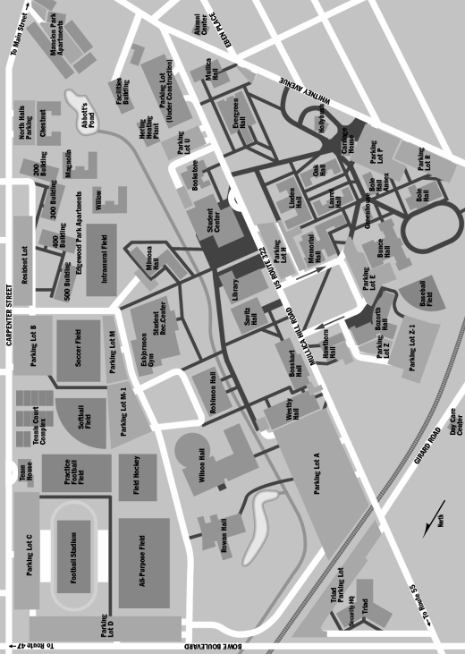

Misc. Info About Sectionals 2000

Hotels
Fairfield Inn Howard Johnson’s
Hurffville Road Blackhorse Pike
Deptford, NJ 08096 Blackwood, NJ 08012
856- 856-

Conference Cost
The cost for Sectionals is $20 if post marked before March 27th.
After March 27th or at the door, the cost is $23.

Additional Costs During the Conference
50/50
Make Your Own Letters ($3 and you need your own shirt)
Conference Shirt ($10)

Pre-Conference Events
Tentative—Brothers coming down the Friday before the conference will be welcome to join us for a movie night.

Post Conference Events
After the conference, Brothers from Nu Theta will be going out to dinner. Anyone interested in attending is welcome.

Also, at 11 p.m. we will be meeting to go to see Pink Floyd’s laser Wall at the Franklin Institute. Show starts at midnight. Cost is $8 per person. Bridge toll is $3, free parking.

All pre- and post-conference events are not included in the cost of the conference

Who Benefits From Sectionals?

The following is a list of everyone who will benefit from Sectionals 2000:

Brothers
Pledges
Alumni
Sectional & Regional Staff
Section 99
Together Inc.
Rowan University
The Mystery Organization (Chosen from the 50/50)
National Wildlife Federation

Be A Leader. Be A Friend. Be Of Service.
Alpha Phi Omega
Registration Form

Chapter: __________________________ School: ________________________________________

Shirt Sizes L, XL, XXL, XXXL

Name | Nickname | E-mail | Status | T-shirt Making Workshop  $3 | Conference Cost  $20 | Shirt  Size  $10 | I plan on attending the post conference dinner?  (Y/N) | Total Cost

Please mail all registration information, by March 27th, to: Total Enclosed $__________________
Alpha Phi Omega
Spring Sectionals Please make all checks payable to Alpha Phi Omega
SGA Suite
Rowan University
Glassboro, NJ 08028

